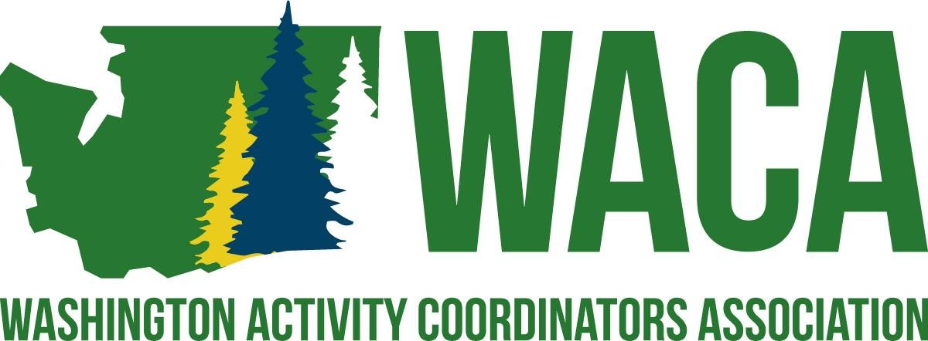

Mission
To serve professionals involved in student activities by providing opportunities and resources for building school culture through project management and professional growth.
​
Vision
WACA supports the development of professionals who are involved in student activities by:
* Hosting a premier conference for all professionals involved in any aspect of student activities.
* Providing professional growth opportunities throughout the year through networking
* Committing to assisting professionals in creating positive school cultures that foster a sense of belonging.

Social Media Coordinator
Purpose: To write, organize and distribute WACA content and communications on all social media platforms.
- Attends all Board of Directors meetings and Executive Board meetings.
- Works with the President in the preparation of Association mailings.
  - Prepares and coordinates the mailing of a conference advertisement to all secondary schools in the fall and winter of each year.
- Actively participates in the planning, implementation and evaluation of the Annual Conference.
  - takes photos throughout the conference
  - posts conference photos on social media in real time at the conference
  - Makes a highlight reel of photos to put on the website post-conference
  - Takes, creates and prints the WACA Board pictures for display.
  - Takes digital pictures of presenters, speakers, area delegates, Hall of Fame and general conference pictures for inclusion on the website.
- Works with the Webmaster and Secretary to enhance the Association social media presence.
  - Creates, develops, or acquires new content to be added to the Association website at least on a quarterly basis. May be in place of a newsletter.
  - Social media committee lead
  - Administrator on all social media accounts
- Create a communications team with the following:
  - Secretary
  - Social Media Coordinator
  - Webmaster
  - Lead Area Representative
  - Each has defined roles and responsibilities in their job descriptions
- May seek opportunities to join other committees within the structure of the Association Bylaws.

Board of Director Responsibilities
All Board Members
- It is a general responsibility that the Board of Directors follow all guidelines and procedures of the Association and that each individual board member meets all responsibilities as outlined in the responsibilities listed below.
- It is expected that board members respond in a timely manner to communications involving Association business.
- Failure to follow guidelines and procedures of the Association or failure to meet minimum job responsibilities is grounds for removal from the board, as outlined in the Bylaws of the Association.
- Actively participates in the planning, implementation, and evaluation of the Annual Conference.
  - Presents breakout sessions, as needed.
  - Participates in the set-up logistics, decorations, and/or other Annual Conference specific committees, as needed.
  - Volunteers for duties at the Annual Conference as needed to fill in the Responsibility Matrix.
  - Solicits donations for delegate giveaways and prizes.
  - Assists in the recruitment of Presenters.
  - Assists in the recruitment of Partners.

