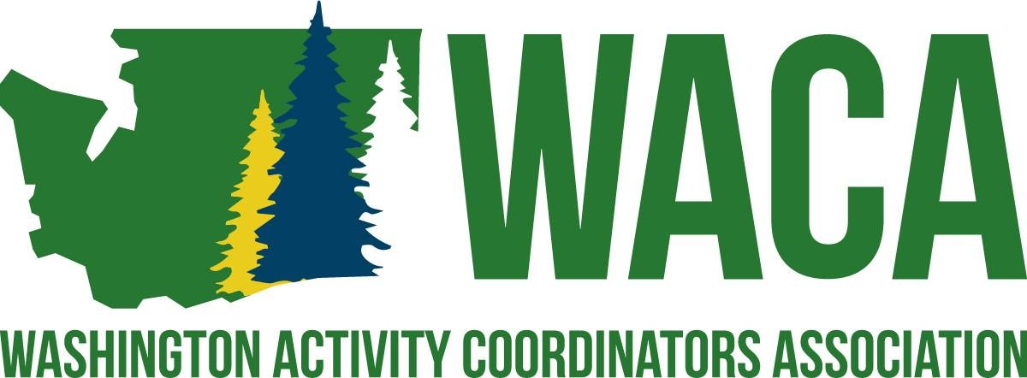

Mission
To serve professionals involved in student activities by providing opportunities and resources for building school culture through project management and professional growth.
​
Vision
WACA supports the development of professionals who are involved in student activities by:
* Hosting a premier conference for all professionals involved in any aspect of student activities.
* Providing professional growth opportunities throughout the year through networking
* Committing to assisting professionals in creating positive school cultures that foster a sense of belonging.
Area Representative
Purpose: To represent the WACA delegates in a similar geographic area and to give them information about WACA and recruit for the conference.
- Attends all Board of Directors meetings.
- Communicates with delegates within their designated area a minimum of four (4) times per school year.
  - Minimum: April/May, September, January, March - before conference
  - Maintains a current contact list for the respective area.
  - Includes the Board of Directors in your area plus the Presidential Trio in the communication with area delegates.
- Actively participates in the planning, implementation and evaluation of the Annual Conference.
  - Collaborate with other Area Reps regarding the content for Area meetings
  - Facilitates Area Meetings schedules during the conference.
  - Advertises and promotes the conference and recruits delegates from their designated area.
  - Coordinates and documents check-in of delegates from their designated area.
- Make seek opportunities to join other committees within the structure of the Association Bylaws, as needed.
Area Rep Coordinator
- Checking that Area Reps send out messages.
- Send messages to the Webmaster.
- Facilitates planning of area meetings at Annual Conference.
- Works with the Communications Team on the current conference communication schedule
- Coordinate four quarterly Area Rep emails per year with the Communications Team and President..
- Manage the area meetings at Exec Board meetings in September and January.
- Make sure agendas and supplies are ready for the conference.
- Serves on the Professional Development Committee with President Elect, High School and Middle School Representatives.

Board of Director Responsibilities
All Board Members
- It is a general responsibility that the Board of Directors follow all guidelines and procedures of the Association and that each individual board member meets all responsibilities as outlined in the responsibilities listed below.
- It is expected that board members respond in a timely manner to communications involving Association business.
- Failure to follow guidelines and procedures of the Association or failure to meet minimum job responsibilities is grounds for removal from the board, as outlined in the Bylaws of the Association.
- Actively participates in the planning, implementation, and evaluation of the Annual Conference.
  - Presents breakout session, as needed.
  - Participates in the set-up logistics, decorations, and/or other Annual Conference specific committees, as needed.
  - Volunteers for duties at the Annual Conference as needed to fill in the Responsibility Matrix.
  - Solicits donations for delegate giveaways and prizes.
  - Assists in the recruitment of Presenters.
  - Assists in the recruitment of Partners.

