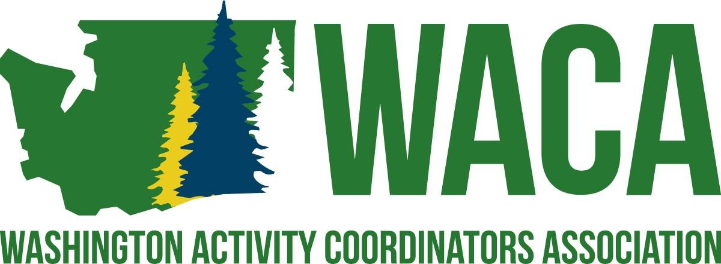

Mission
To serve professionals involved in student activities by providing opportunities and resources for building school culture through project management and professional growth.
​
Vision
WACA supports the development of professionals who are involved in student activities by:
* Hosting a premier conference for all professionals involved in any aspect of student activities.
* Providing professional growth opportunities throughout the year through networking
* Committing to assisting professionals in creating positive school cultures that foster a sense of belonging.

Program Coordinator
Purpose: To oversee the programming for the entire conference, from classes, to workshops, to speakers and anything in between.
- Attends all Board of Director meetings and Executive Board meetings.
- Actively participates in the planning, implementation and evaluation of the Annual Conference.
  - Coordinates the recruitment and selection of presenters for Professional Growth Breakout Sessions.
    - Creates conference schedule with the President
    - Gather details and information regarding all Professional Growth Breakout Sessions.
    - Coordinates the placement (time and location), within the program, of each Professional Growth Breakout Sessions..
    - Confirms with presenters the times and location of their presentations.
    - Coordinates with each presenter and the conference venue for audio and visual needs and set-up.
    - Collects data on the participation of each Professional Growth Breakout Sessions.
    - Prepares certificates/recognition for each presenter.
  - Coordinates the Pre-Conference Professional Growth Workshops.
    - Works with the President in the selection of presenters for the Pre-Conference Professional Growth Workshops.
    - Coordinates the location of each Pre-Conference Professional Growth Workshops.
    - Confirms with presenters the times and location of their presentations.
    - Coordinates with each presenter and the conference venue for audio and visual needs and set-up.
  - Coordinates the implementation of other aspects (Speaker Showcase, Meet the Pros, Book the Pros, etc.) of the conference, based on the final program.
    - Coordinates the recruitment and selection of presenters and topics.
    - Coordinates with the conference venue for audio and visual needs and room set-up. (BEO’s)
  - Creates the conference program, online program choices, i.e. Sched.
- Leads in the building of the digital conference program app, assists others able to support this task.
- Participates with the Annual Conference Site Committee, as needed.
- Head of the Programming Committee.
- Attend pre-conference BEO (Banquet Event Orders) meeting
- Make sure AV is good for presenters
- May seek opportunities to join other committees within the structure of the Association Bylaws.

Board of Director Responsibilities
All Board Members
- It is a general responsibility that the Board of Directors follow all guidelines and procedures of the Association and that each individual board member meets all responsibilities as outlined in the responsibilities listed below.
- It is expected that board members respond in a timely manner to communications involving Association business.
- Failure to follow guidelines and procedures of the Association or failure to meet minimum job responsibilities is grounds for removal from the board, as outlined in the Bylaws of the Association.
- Actively participates in the planning, implementation, and evaluation of the Annual Conference.
  - Presents breakout session, as needed.
  - Participates in the set-up logistics, decorations, and/or other Annual Conference specific committees, as needed.
  - Volunteers for duties at the Annual Conference as needed to fill in the Responsibility Matrix.
  - Solicits donations for delegate giveaways and prizes.
  - Assists in the recruitment of Presenters.
  - Assists in the recruitment of Partners.

