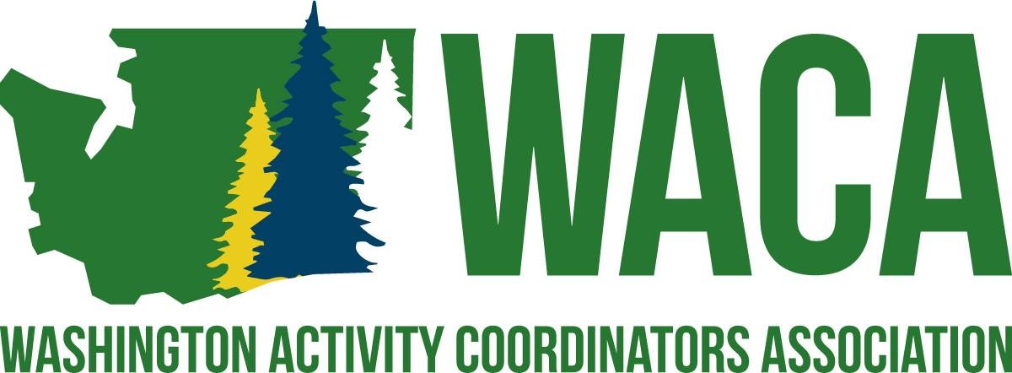

Mission
To serve professionals involved in student activities by providing opportunities and resources for building school culture through project management and professional growth.
​
Vision
WACA supports the development of professionals who are involved in student activities by:
* Hosting a premier conference for all professionals involved in any aspect of student activities.
* Providing professional growth opportunities throughout the year through networking
* Committing to assisting professionals in creating positive school cultures that foster a sense of belonging.

High School Representative
Revised Purpose: To support WACA’s High Level Delegates, work with the High School Rep on content that is useful and relevant to the delegates, and support the Hall of Fame Committee
- Attends all Board of Directors meetings and Executive Board meetings.
- Lead year round Professional Growth opportunities, including, but not limited to
  - WACA Wednesday
  - Lead the Professional Growth 3-hour Workshops at Annual Conference with assistance from other board members.
  - Share/Create an activity or lesson for the WACA Quarterly Newsletter
  - Using data from the delegates, design professional growth opportunities as needed.
- Mentoring: Look for opportunities to develop mentor relationships
- Works with the Recognition Coordinator and Middle School Rep in coordinating the Hall of Fame program.
  - Coordinates the advertising and collection of nominations.
  - Maintains the nomination records and collects additional information, as needed.
  - Shall formally present all candidates for Hall of Fame using comparable info and Recognition Coordinator.
    - Coordinates Hall of Fame voting process with High School Rep and Recognition Coordinator.
    - Notifies family and colleagues of inductees and coordinates their participation in the banquet.
    - Invite all past inductees to the Hall of Fame banquet.
  - Active member of the Hall of Fame Legacy Committee.
    - Shall meet with the High School Rep and Recognition Coordinator to determine the qualifications of legacy candidates for the Hall of Fame.
    - Shall formally present Legacy Hall of Fame inductee to the Board of Directors at the Winter Board Meeting.
    - Notifies family and colleagues of inductees and coordinates their participation in the banquet.
- A part of the Professional Development Committee with President-Elect, Middle School Rep and Area Rep.
- Actively participates in the planning, implementation with High School Rep and evaluation of the Annual Conference.
  - Assists Area Representatives, as needed.
- May seek opportunities to join other committees within the structure of the Association Bylaws.

Board of Director Responsibilities
All Board Members
- It is a general responsibility that the Board of Directors follow all guidelines and procedures of the Association and that each individual board member meets all responsibilities as outlined in the responsibilities listed below.
- It is expected that board members respond in a timely manner to communications involving Association business.
- Failure to follow guidelines and procedures of the Association or failure to meet minimum job responsibilities is grounds for removal from the board, as outlined in the Bylaws of the Association.
- Actively participate in the planning, implementation, and evaluation of the Annual Conference.
  - Present breakout session, as needed.
  - Participate in the set-up logistics, decorations, and/or other Annual Conference specific committees, as needed.
  - Volunteer for duties at the Annual Conference as needed to fill in the Responsibility Matrix.
  - Solicits donations for delegate giveaways and prizes.
  - Assist in the recruitment of Presenters.
  - Assist in the recruitment of Partners.

